

Dr. John, Gould inc.
2017-01-29
Dr. Gould
79699 Williams Ville Suite 183, West Deannaland, FL 54610
Phone: 2143841355
Fax: 3680942507

Re: Brianna, Cooper
PHN: 603454331
Birthdate: 19-Jan-1968
Address: 06780 Andrews Highway, East Kellyview, TN 61607
Patient number: 3582780573

To Whom It May Concern:

This is a medical letter to state the above patient is pregnant with expected delivery date of 22-Apr-2025. Hoping this information is satisfactory for your requirements.

Thank you.

Sincerely,
Dr. John, Gould
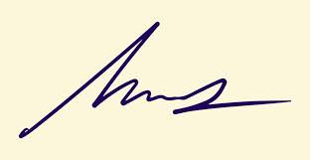
FRCS© NCMP
Clinical Assistant Professor, UBC
Department of Obstetrics and Gynecology SMH

